
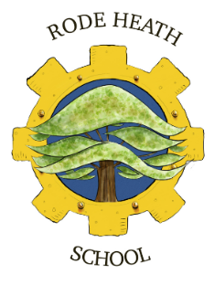
25/09/24
Dear Parents/Carers,
We have arranged an exciting visit for the Year 3 children to the National Waterways Museum at Ellesmere Port on Thursday 3rd October 2024 as part of their work on Canals.
We aim to leave school at 9.05am and return for about 3.35pm. Your child needs a packed lunch and a non-fizzy drink in a plastic bottle. They will need a ruck-sack so they are hands free throughout the visit. Children will be required to wear their school uniform for the trip. Please remember to bring a suitable coat and wear suitable footwear.
The cost of the trip is £20.50, payment and consent can be accessed and completed via your scopay account. Please complete online by Friday 27th September to secure your child’s place.

Yours sincerely
Mr Randall
Mr Randall
Year 3 Teacher

