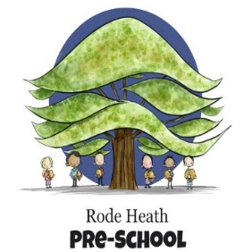
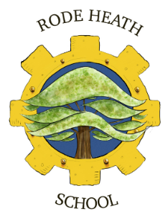
Monday 16th September, 2024

Dear Parents/Carers,
This term our history focus is on Ancient Egypt and to enhance the children’s experience of this fascinating period, we have booked a trip to the Macclesfield Silk Museum on Monday 30th September. The day will consist of three workshops, including a tour of the exhibition run by Miss Marianne Brocklehurst (in costume), an object handling session where the children are curators, and a Scarab Pectoral making activity.
We will be leaving school at 9:15 am and aim to be back for the end of the school day. The cost of the trip will be £20, please consent and make payment via your scopay account. Payment must be made by Friday 27th September.
We are offering the facility to order a school packed lunch for this trip (children who receive Pupil Premium or FSM will automatically receive a school packed lunch), please choose the lunch option you child will be taking via your scopay account. The sandwich options will be Ham, Tuna or cheese and charged @ £3.40. The children will also need to bring a couple of drinks (no cans or glass bottles please!) in a suitable hands-free bag such as a rucksack. The children need to wear school uniform and bring a waterproof coat.
Kind regards

Mrs Wiskow & Mrs Pecora

