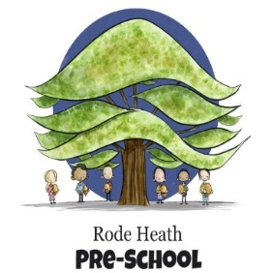
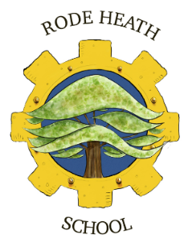

Jodrell Bank – Year 5 Trip

Dear Parents/ Carers,
As part of our topic study about Space, we are going to visit the Jodrell Bank Observatory in Lower Withington on Monday 21st October 2024. We aim to leave school at 9.20am and return before the end of the school day at 3.00pm. Your child will need a packed lunch, snack and a drink (no fizzy drinks, or glass bottles, please). Please ensure your child wears school uniform for our trip to the observatory. Also, please can your child bring a waterproof coat due to the time of year and suitable footwear.
The cost of this trip is £19.30, payment and consent can be made and completed via your online Scopay account. Please complete by Friday 11th October to secure your child’s place.
If you have any queries regarding this trip, please do not hesitate to contact me.

Yours sincerely,
Miss Watson

