
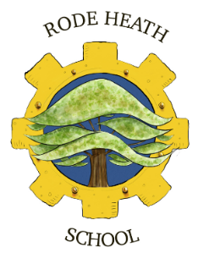

Thursday 17th October 2024
Dear Y6 Parents
You may remember at the end of last year, we were lucky enough to take part in a Centre for Industry Education Collaboration project (CIEC), which involved visits from a STEM ambassador from Uniper, a multi-national energy company.
As a result, we have been invited to visit Connah’s Quay, one of the few power stations remaining in the UK. The trip has been arranged for Wednesday 6th November and will be free of charge. The costs of the coach will be funded by school. This visit fits in well with our science curriculum, as we will be studying electricity next half-term, and provides an excellent opportunity for the children to see a power station at first hand.
We will be leaving school at 9:15 am and aim to be back around 4pm. The children will need a packed lunch and a couple of drinks (no cans or glass bottles please!) in a suitable hands-free bag such as a rucksack. The children need to wear school uniform and bring a waterproof coat.
We will require consent for your child to attend, please do this via your scopay account.
Kind regards

Mrs Wiskow

