|  |
| --- |
|  |
|  | | |

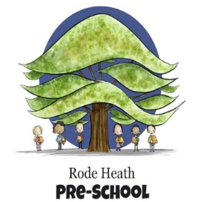23rd January 2025

Dear Parents/Guardians,

Arrangements are currently being finalised for the Year 2 residential visit to Llandudno, staying at the Llandudno hostel for one night on Wednesday 14th May – Thursday 15th May 2025.

On the first day, the children will visit the seaside town of Conwy. We will be visiting the castle and the smallest house before proceeding to Llandudno where we will get the opportunity to visit the beach and have a sandcastle competition. The following day we will be walking to the Boathouse Climbing Centre where we will spend the morning climbing, crawling and scrambling our way through the building when we take on indoor climbing, tunnels and abseiling. We will then set off to Happy Valley on the search for the famous Alice in Wonderland Statues and a spot of lunch before heading home.

The cost of the trip will be £125.00. A non- refundable deposit of £25.00 will be required to secure your child’s place. We would dearly like all children to take part in this visit, especially as the trip will be the focus of our summer-term curriculum, but appreciate that financially this might be difficult for some. If you feel you will find payment difficult, please get in touch with Mr. Frankland. Parents may wish to spread the cost by paying over the next few months leading up to the trip. This can be done by using our online payments system which enables you to track all your payments and any outstanding balance due.

In order for your child to attend this trip you will need to give permission, this is now done via the online payments system, please log-in and tick the consent box before making the deposit payment. There will be a Residential Meeting for parents in due course and we shall share with you a detailed itinerary and you will have the chance to raise any questions you might have.

**If your child will not be attending this trip, please let the school office know immediately so that we can make the relevant alterations to the trip ahead of time.**

Yours sincerely,

Miss Moss