|  |
| --- |
|  |
|  | | |
|  |

Dear Parents/Guardians, January 2025

**Bushcraft Residential Trip to Kibblestone Scout Camp for Year 3**

I am pleased to announce that Year 3 will be going on an exciting trip to Kibblestone Scout Camp for their residential on **Thursday 12th June to Friday 13th June 2025.** This will be the ninth time we have done this type of residential and it offers a tremendous opportunity for ‘Living off the Land’ The children will sleep in tents large enough for 6 per tent.

The approximate cost is £115.50 **Please consent and pay your £25 deposit via your scopay account.** The deposit and any further payments towards the trip can be made via your online SCOPAY Account. (The total cost may change dependent on uptake) Permission for your child to attend this trip will need to be given prior to paying the deposit, this can be done by ticking the consent box before making payment.

**The table below shows items that your child will need for the trip:**

|  |  |
| --- | --- |
| * Large rucksack (or alternative bag/suitcase) | * Wellington boots (wear them on the day) |
| * Warm sleeping bag (pillow if you want) | * Trainers or old walking shoes |
| * Roll mat | * towel |
| * Tracksuit/hardwearing trousers x2 | * bag for wet clothing |
| * underwear | * toiletries |
| * T-shirts x2 | * Warm hat |
| * Waterproof jacket and trousers | * Gloves |
| * Warm socks x2 | * Water bottle |
| * nightwear | * good torch with fresh batteries |

Bring a packed lunch in a disposable bag on the Thursday.

* There will be Bushcraft leaders for the activities but catering will be done by myself and Mrs Dobson.

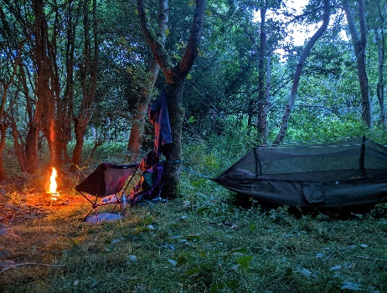Yours sincerely

Mr Randall

[Scouting and Guiding | Kibblestone Campsite](https://www.kibblestone.org/stay/scouting-and-guiding)