
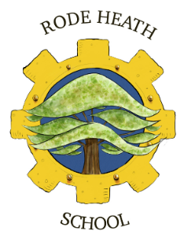
Tuesday 21st January, 2025
Dear Parents
This term our history focus is on the Ancient Greeks and to enhance the children’s experience of this fascinating period, we have booked a trip to the Manchester Art Gallery on Wednesday 5th February. The day will consist of two 1.5-hour workshops: The Story of Troy (combining interactive storytelling, artefacts, and art) and Frieze Framed, during which the children will be supported to create a personal sketchbook.
We will be leaving school at 9:00 am and aim to be back by 3:30pm. The cost of the trip will be £23.50, please pay this balance via your scopay account and consent to your child attending. The children will need a packed lunch and a couple of drinks (no cans or glass bottles please!) in a suitable hands-free bag such as a rucksack. The children need to wear school uniform and bring a waterproof coat.

Kind regards

Mrs Wiskow & Mrs Pecora

