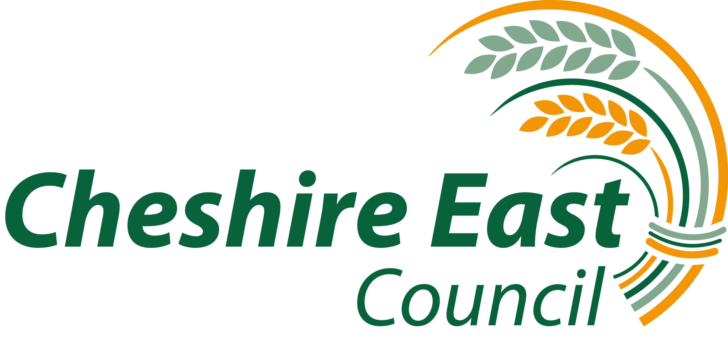

INSTRUMENT OF GOVERNMENT

1. The name of the school is Rode Heath Primary School.

2. The school is a community school.

- The name of the governing body is “ The governing body of Rode Heath Primary School“

4. The governing body shall consist of:

(a) 2 parent governors;

(b) 1LA governor;

(c) 1 staff governor;

(d) The Head Teacher unless the Head Teacher resigns the office of governor in accordance with Regulation 19.1;

(e) 7 co-opted governors.

- Total number of governors 12.

6 This instrument of government comes into effect on 1 September 2014.

7 This instrument was made by order of the Cheshire East Council on 18 July 2014.

8 A copy of the instrument must be supplied to every member of the governor
body ( and the Headteacher if not a governor ).

